LAB Assignment No. 5
Topic: Artificial Neural Network Model

Question 1
Logic Gates with Neural Network. Implement a feed-forward neural network to learn the AND gate.
- Inputs: (0,0), (0,1), (1,0), (1,1)
- Output: 0, 0, 0, 1
Tasks:
- Create dataset using NumPy or pandas.
- Build a neural network with one hidden layer using TensorFlow/Keras or PyTorch.
- Train it and show accuracy.
- Compare model predictions with actual outputs
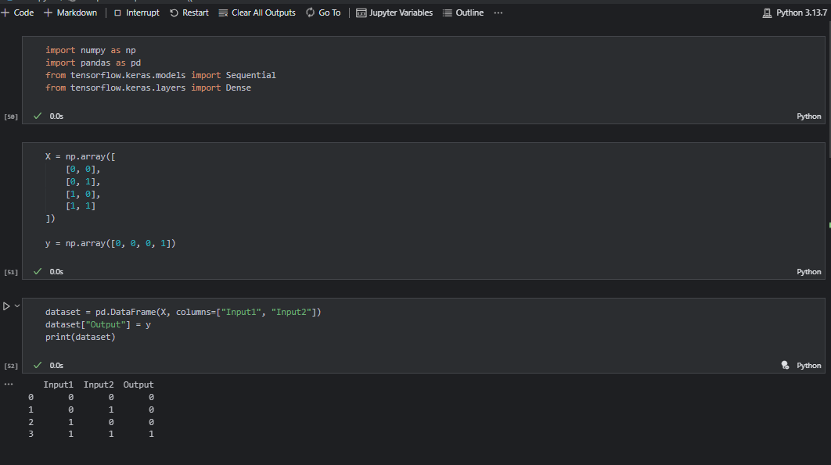
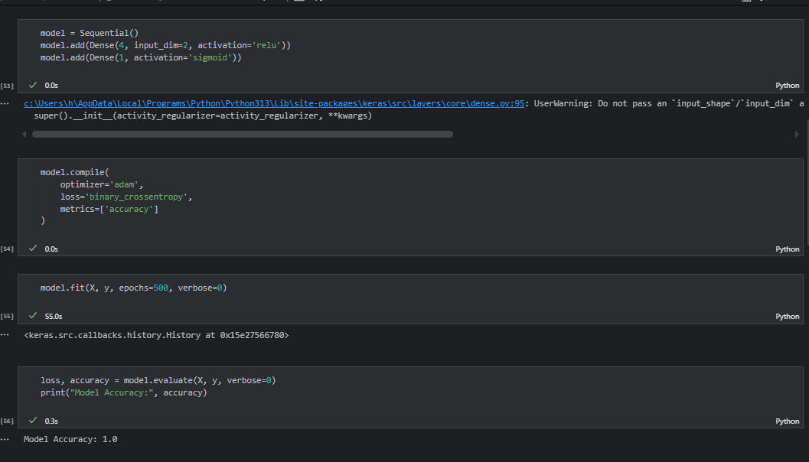
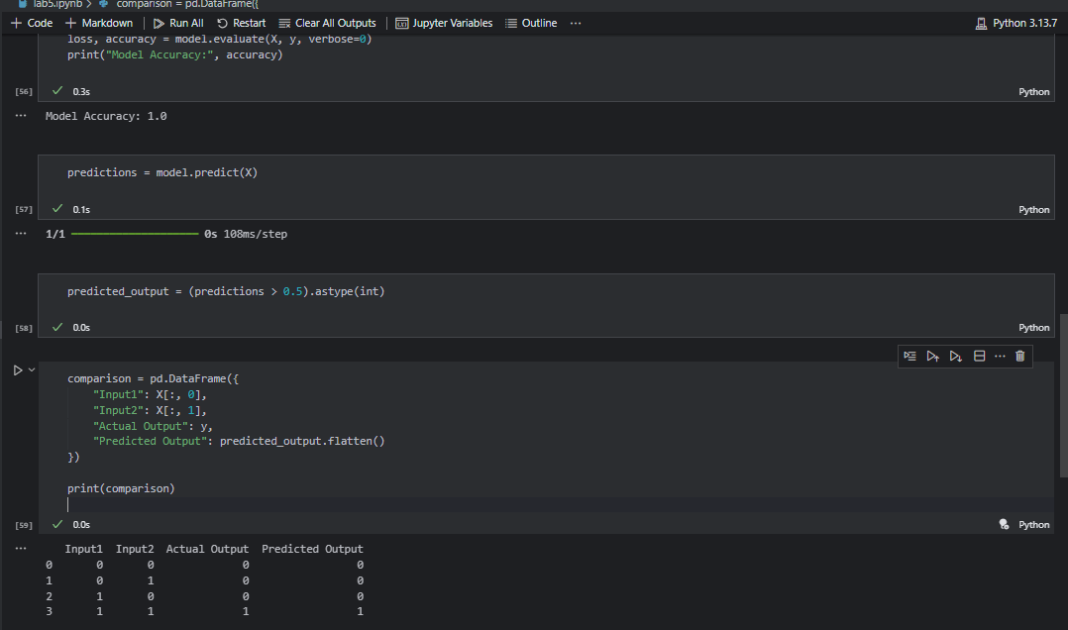

Question 2
Create a dataset y = x² + noise for x in range [-3,3]. Regression Task with Neural Network
Tasks:
- Generate 100 samples.
- Build a neural network to predict y from x.
- Plot actual vs. predicted results.
- Discuss how increasing hidden neurons changes results.
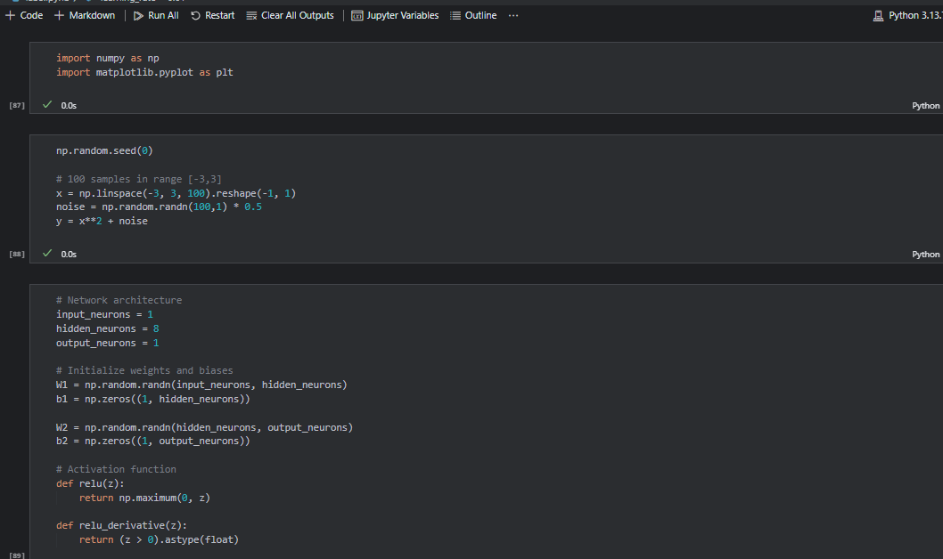
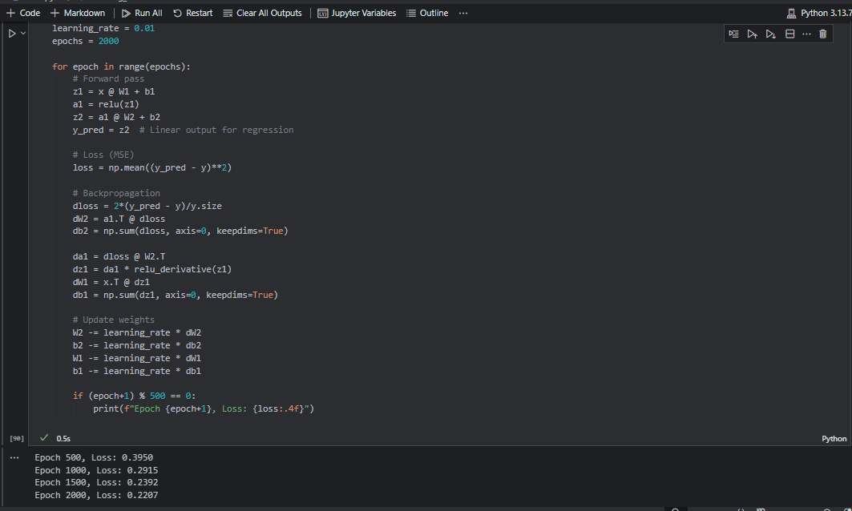
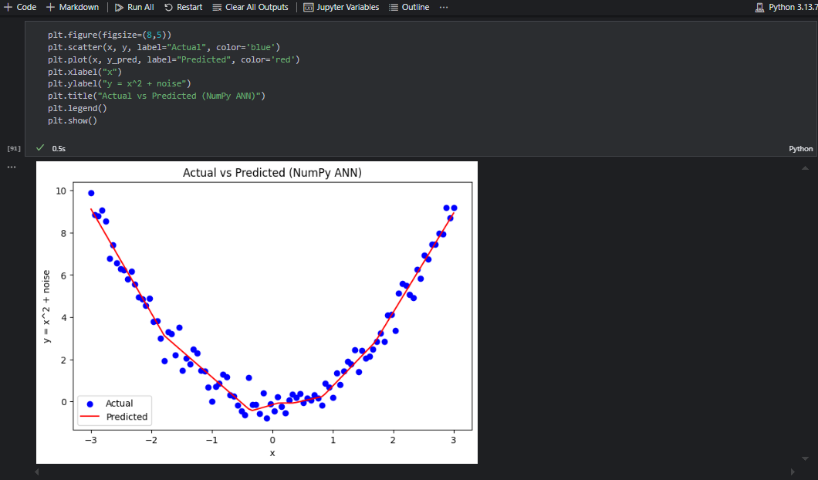
Question 3:
Use the XOR gate and train networks with different activation functions (sigmoid, tanh, ReLU).
- Compare accuracy, loss, and convergence speed.
- Plot and discuss results.
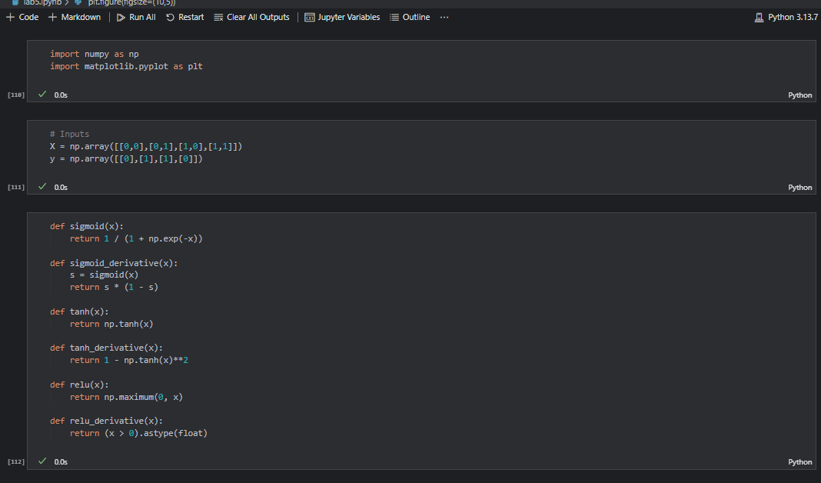
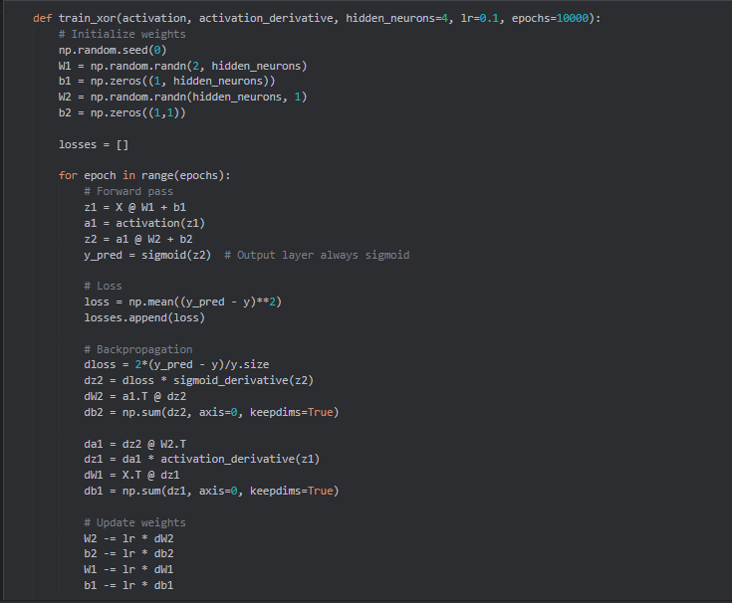
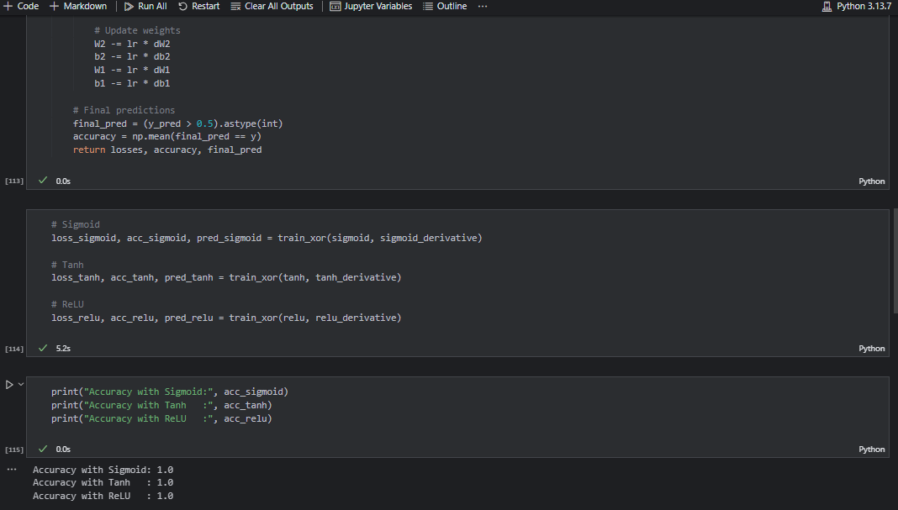
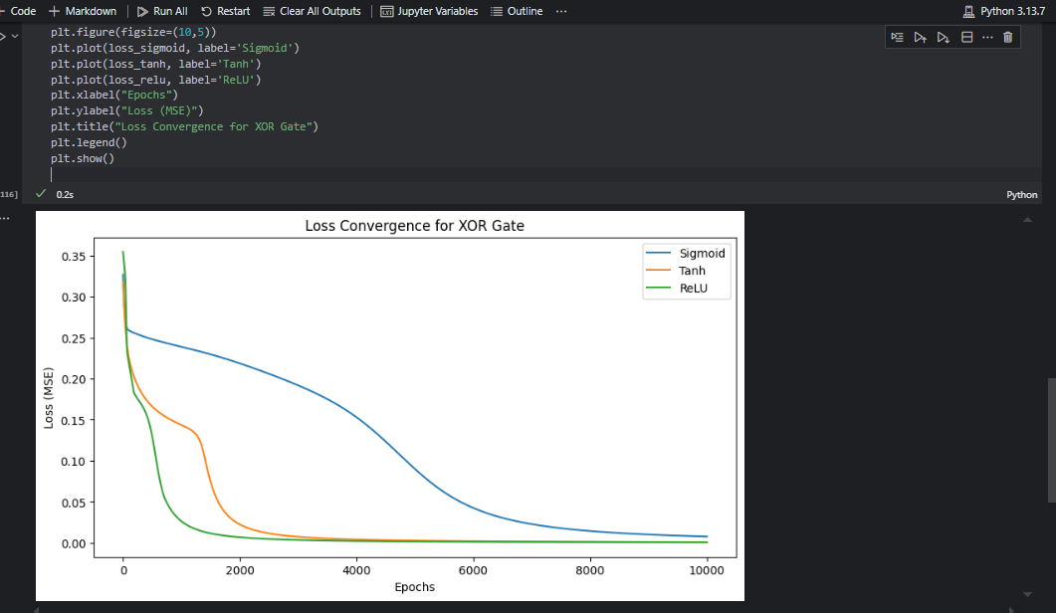

Question 4
Binary Classification using Neural Network
Objective: Build a neural network to classify whether a tumor is malignant or benign using the Breast Cancer dataset.
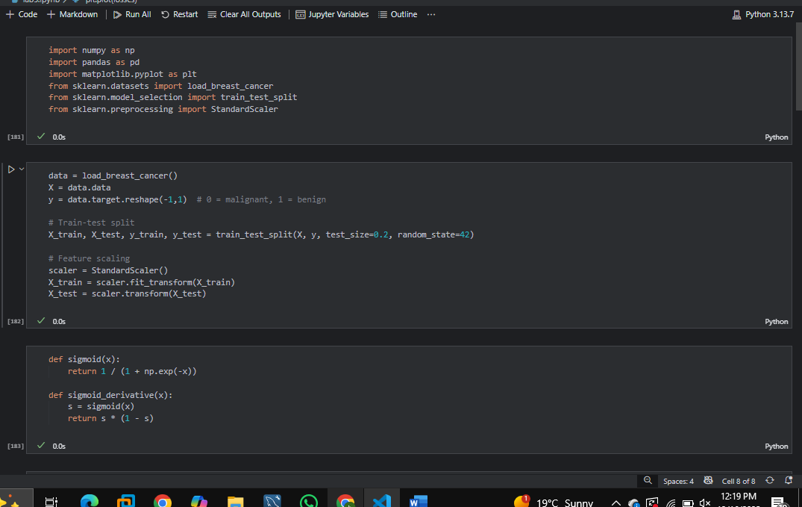
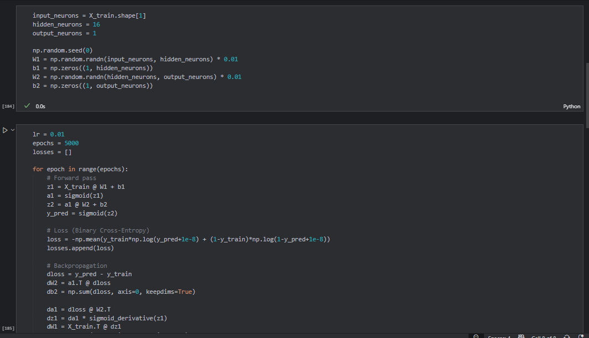
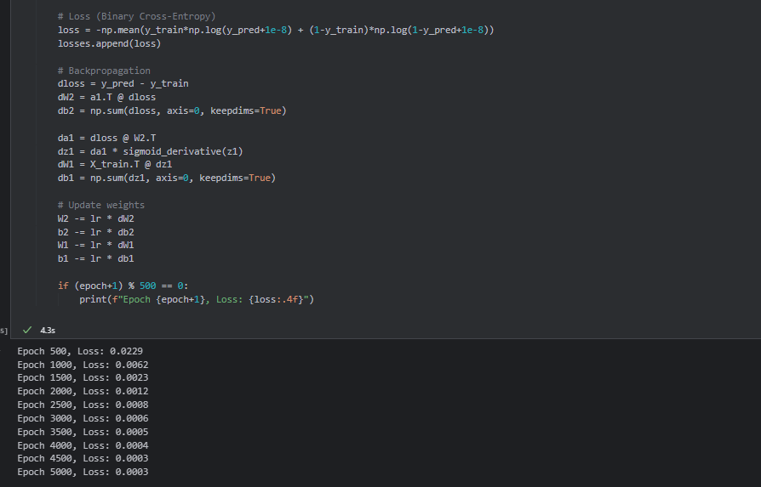
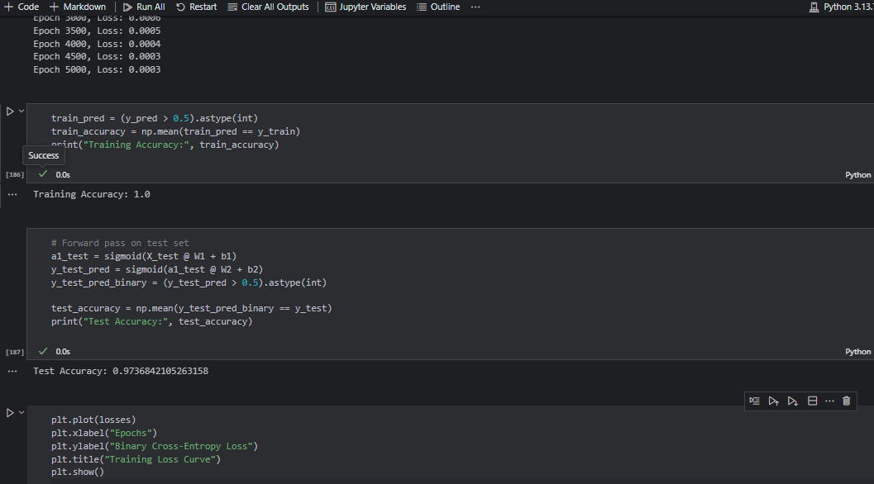
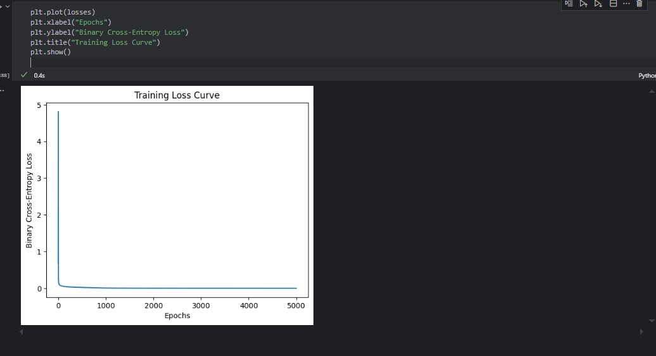

Question 5
Multi-Class Classification on Iris Dataset
Objective: Train a neural network to classify flower species (Setosa, Versicolor, Virginica).
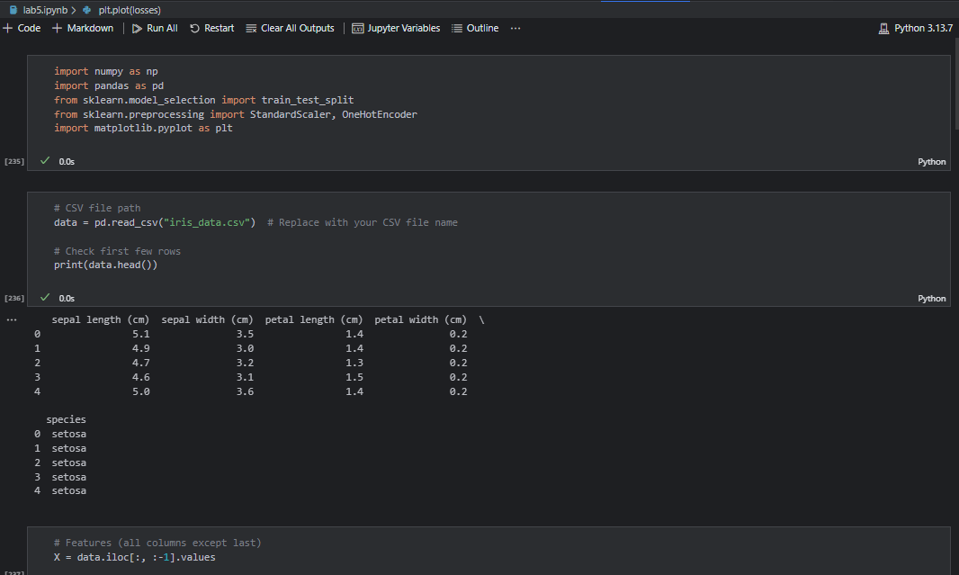
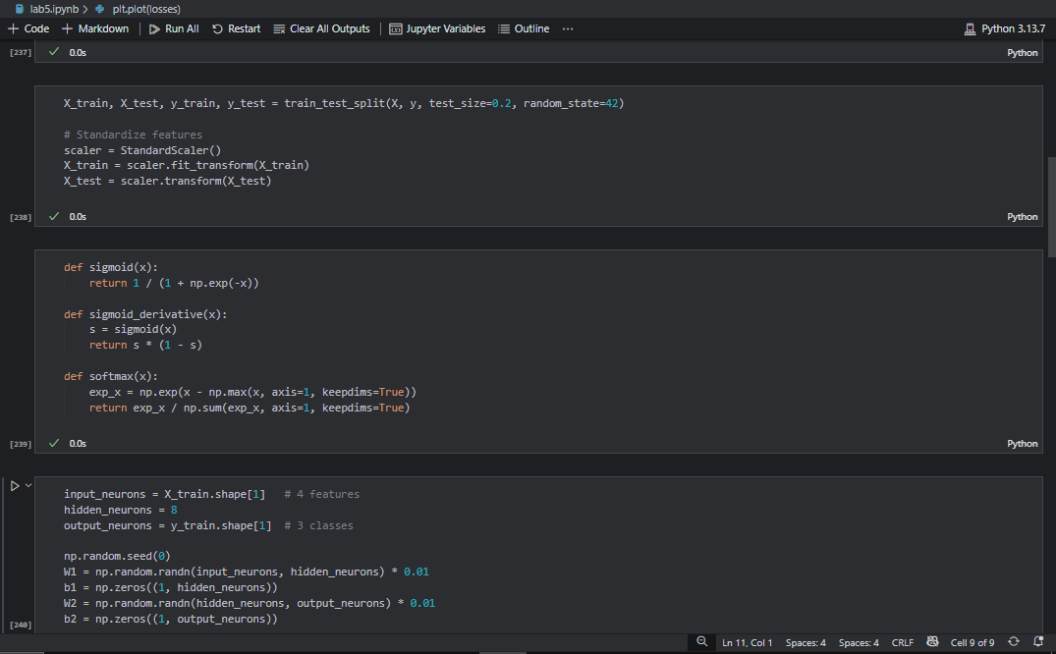
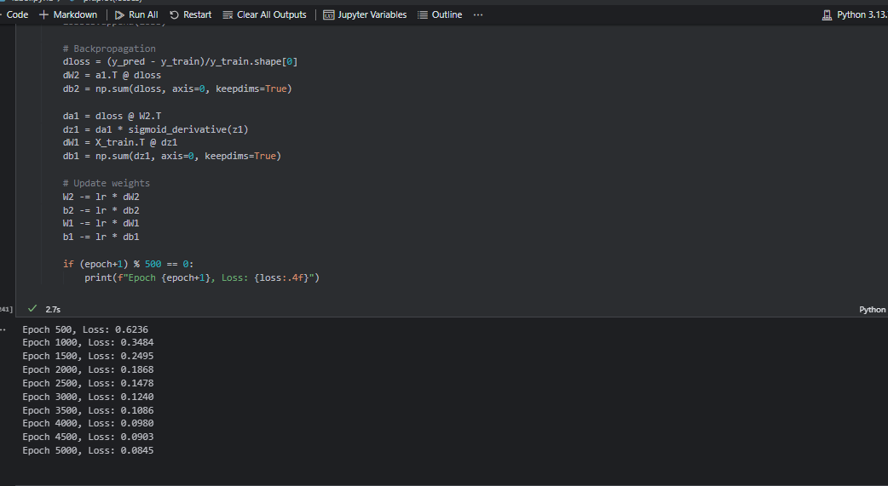
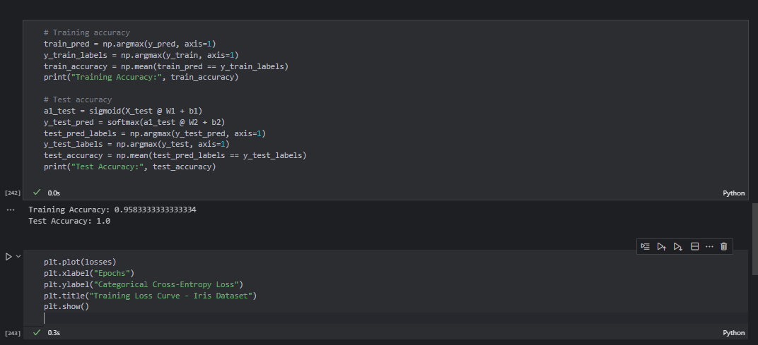
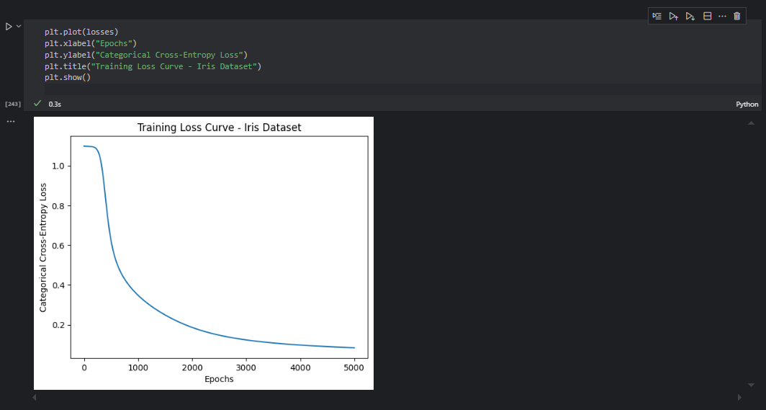
Question 6
Regression Problem (House Price Prediction)
Objective: Predict house prices using the California Housing dataset.
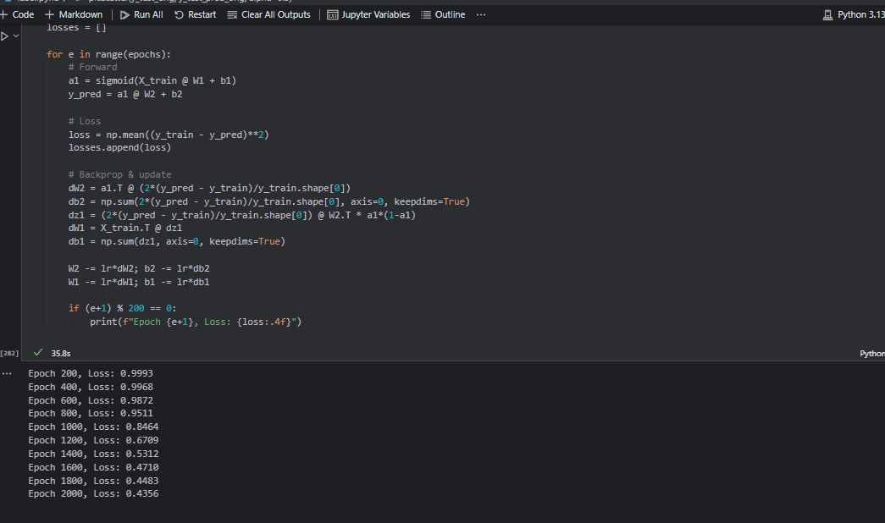
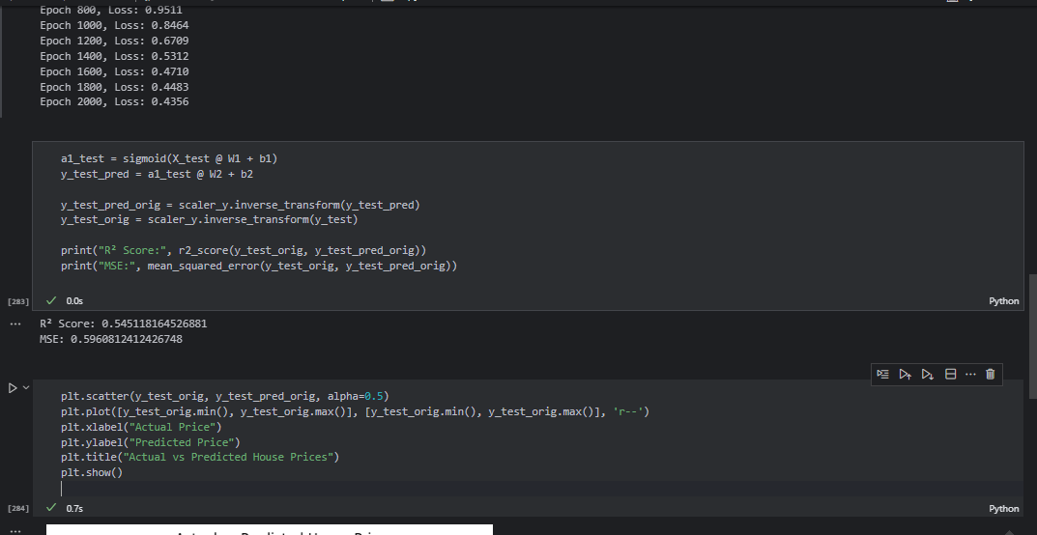
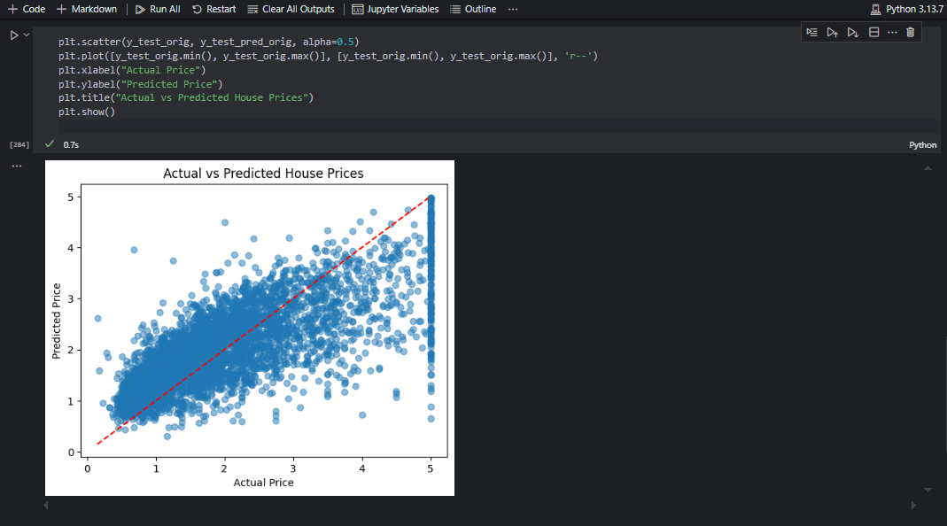
Question 7
Neural Network with Dropout Regularization
Objective: Prevent overfitting using Dropout layers on the MNIST digit dataset.
